Schedule
A series of operation from one transaction to another transaction is known as schedule. It is used to preserve the order of the operation in each of the individual transaction.
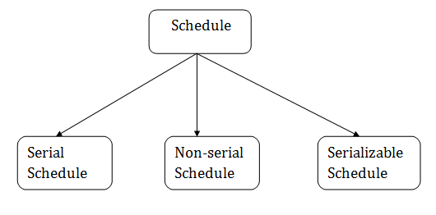

1. Serial Schedule
The serial schedule is a type of schedule where one transaction is executed completely before starting another transaction. In the serial schedule, when the first transaction completes its cycle, then the next transaction is executed.
For example: Suppose there are two transactions T1 and T2 which have some operations. If it has no interleaving of operations, then there are the following two possible outcomes:
- Execute all the operations of T1 which was followed by all the operations of T2.
- Execute all the operations of T1 which was followed by all the operations of T2.
- In the given (a) figure, Schedule A shows the serial schedule where T1 followed by T2.
- In the given (b) figure, Schedule B shows the serial schedule where T2 followed by T1.

2. Non-serial Schedule
- If interleaving of operations is allowed, then there will be non-serial schedule.
- It contains many possible orders in which the system can execute the individual operations of the transactions.
- In the given figure (c) and (d), Schedule C and Schedule D are the non-serial schedules. It has interleaving of operations.

3. Serializable schedule
- The serializability of schedules is used to find non-serial schedules that allow the transaction to execute concurrently without interfering with one another.
- It identifies which schedules are correct when executions of the transaction have interleaving of their operations.
- A non-serial schedule will be serializable if its result is equal to the result of its transactions executed serially.
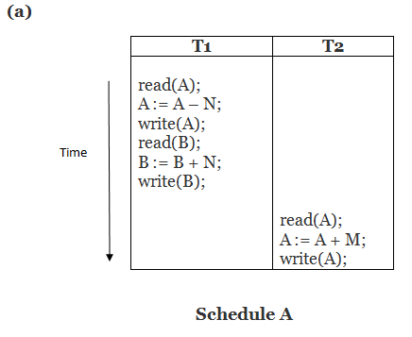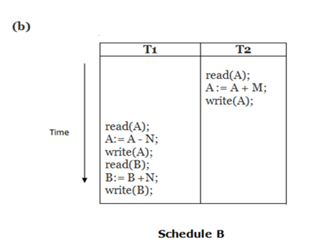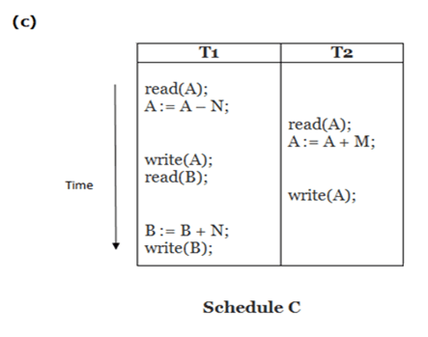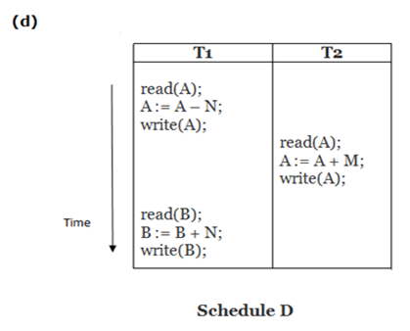
Here,
Schedule A and Schedule B are serial schedule.
Schedule C and Schedule D are Non-serial schedule.

Testing of Serializability
Serialization Graph is used to test the Serializability of a schedule.
Assume a schedule S. For S, we construct a graph known as precedence graph. This graph has a pair G = (V, E), where V consists a set of vertices, and E consists a set of edges. The set of vertices is used to contain all the transactions participating in the schedule. The set of edges is used to contain all edges Ti ->Tj for which one of the three conditions holds:
- Create a node Ti → Tj if Ti executes write (Q) before Tj executes read (Q).
- Create a node Ti → Tj if Ti executes read (Q) before Tj executes write (Q).
- Create a node Ti → Tj if Ti executes write (Q) before Tj executes write (Q).
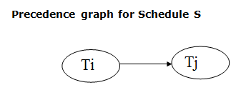
- If a precedence graph contains a single edge Ti → Tj, then all the instructions of Ti are executed before the first instruction of Tj is executed.
- If a precedence graph for schedule S contains a cycle, then S is non-serializable. If the precedence graph has no cycle, then S is known as serializable.

For example:
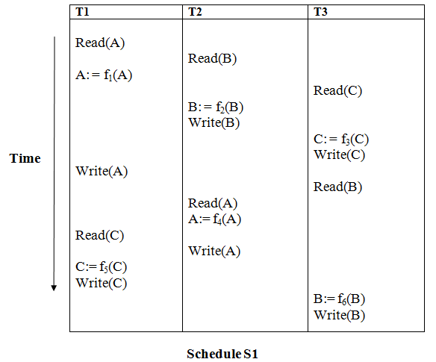
Explanation:
Read(A): In T1, no subsequent writes to A, so no new edges
Read(B): In T2, no subsequent writes to B, so no new edges
Read(C): In T3, no subsequent writes to C, so no new edges
Write(B): B is subsequently read by T3, so add edge T2 → T3
Write(C): C is subsequently read by T1, so add edge T3 → T1
Write(A): A is subsequently read by T2, so add edge T1 → T2
Write(A): In T2, no subsequent reads to A, so no new edges
Write(C): In T1, no subsequent reads to C, so no new edges
Write(B): In T3, no subsequent reads to B, so no new edges

Precedence graph for schedule S1:
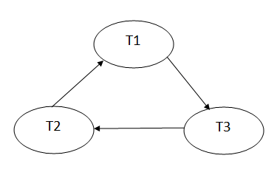
The precedence graph for schedule S1 contains a cycle that's why Schedule S1 is non-serializable.
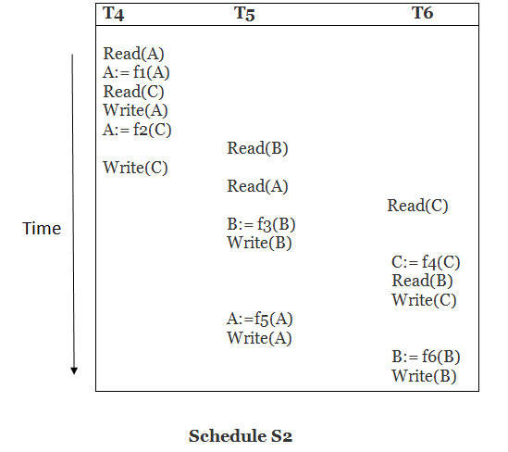
Explanation:
Read(A): In T4,no subsequent writes to A, so no new edges
Read(C): In T4, no subsequent writes to C, so no new edges
Write(A): A is subsequently read by T5, so add edge T4 → T5
Read(B): In T5,no subsequent writes to B, so no new edges
Write(C): C is subsequently read by T6, so add edge T4 → T6
Write(B): A is subsequently read by T6, so add edge T5 → T6
Write(C): In T6, no subsequent reads to C, so no new edges
Write(A): In T5, no subsequent reads to A, so no new edges
Write(B): In T6, no subsequent reads to B, so no new edges

Precedence graph for schedule S2:
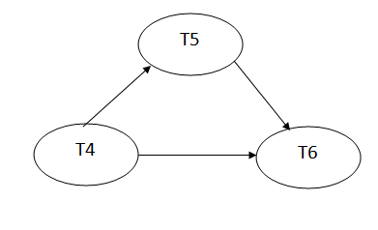
The precedence graph for schedule S2 contains no cycle that's why ScheduleS2 is serializable.

